Overview:

Purpose: Modelling a diagram that can give a user a more accurate representation of how Royal Empress harvesting companies’ production rate and harvesting rate affects their profit.
- Agents: harvesters (observer/harvesting company), tree, patches (soil)
- Variables: harvesting rate (set), planting rate (set), height of the tree (random) , cost of seedling (user controlled), price/foot per harvested tree (user controlled), number of trees (user controlled), hours to harvest/hours to plant (user controlled), workers to plant/workers to harvest (user controlled), wages paid to workers (user controlled)
- Scales: 1 tick= 1 month, 1 patch= 6.1x6.1m
Scheduling:
- Determine the tree position
- add and subtract trees based on height (user)
- Compute the overall profit of the timber harvesting company based on harvesting rate, planting rate, costs of trees (planting and harvesting, as well as the wages that are paid to employees.

Design:

Basic Principles:
Modelling what both the layout of the trees and the profits of the timber company would look like based on planting/cutting down procedures during the timber harvesting season.
Emergence:
Observing how many trees have been cut and planted and what profit will look like each month. Timber harvesters are going to look for the location of trees and the quantity of trees that they should plant and harvest
Adaptation:
The harvesting company will only cut down trees once they have reached a height of 30 feet, and use the height of the tree to determine value. Agents will harvest and plant at their own individual rates unless no space is available for either case.
Objectives:
Harvesting company wants to make money and profit each time they cut down a tree and plant a new one. They have to be able to have some money made even after spending money to plant a new tree including on wages.
Learning Prediction:
N/A
Sensing:
Arranging trees so they are 6.1 meters apart and waiting until they are 30 feet tall to cut them down (map it out). Agents can also sense empty patches as potential planting spots.
Interaction:
- Agents interact with the environment by changing patch heights. A harvested tree has its height reduced to 0 meaning "dirt" and a planted tree starts with a height of 1 ft.
Stochasticity: None
Collectives: The overall harvesting and planting rate of the company will be upheld by the sums over all individual harvested and planted trees.
Observation:
- A plot of overall profit

Description:
- Setup: Once at the beginning
Initialize:
- Patches set to dirt by default
- Trees: random
- Agents determine their individual harvesting and planting rates
- The company determines how many workers to hire to keep those rates.
- Go: Runs every tick, harvest, plant, tree growth (every ticks adds 1.25 ft in height to trees). Also plots monthly profit computed using the following equation;

totalprofit = (Hp Wp Mh Pt) - (Hh Wh Mh Ht) - (Pr Cs) + Hr( 250+12.50Ms)

→ represents loss per month due to planting
→ represents loss per month due to harvesting
→ represents loss per month due to cost per seedling
→ represents gain in monthly profit due to trees sold

Hp= hours needed to plant
Wp= workers needed to plant one tree
Mh= wages per hour
Pt= trees planted in the month

Hh= hours needed to harvest
Wh= workers needed to harvest one tree
Mh= wages per hour
Ht= trees harvested in the month

Pr= monthly planting rate
Cs= cost per seedling

Ht= trees harvested in the month
Ms=price per additional foot of tree sold

totalhours = (Hh Ht) + (Hp + Pt)

Hh = hours needed to harvest
Ht = trees harvested in the month

Hp= hours needed to plant
Pt= trees planted in the month

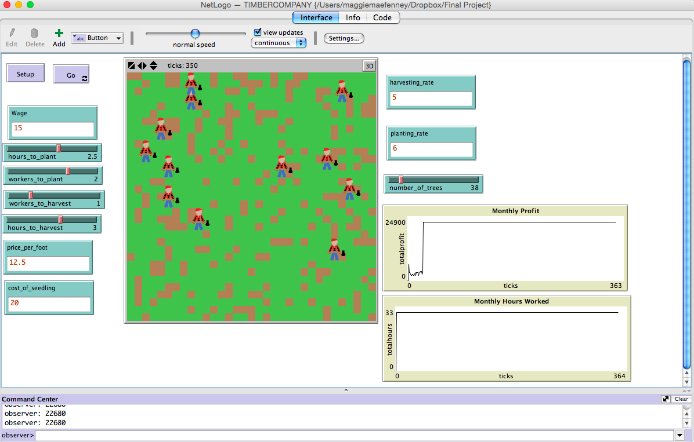
- The “Setup” and “Go” buttons enable the experiment to be run.
  - When the user clicks Setup, the screen will begin preparing itself to run the experiment.
- The “Wage” input is what controls how much each worker is paid per hour of working. Underneath the Wage button is a slider that read “hours_to plant”, “workers_to_plant”, “workers_to_harvest”, and “hours_to_harvest”.
  - Keep in mind that all of these are adjustable depending on what the user would like to see happen in the interaction.
- The “price_per_foot” and “cost_of_seedling” are inputs that are controlled by the user. The price/cost for each is dependent on the user's selection and needs.
  - The one pictured in the model is based on the default Royal Empress Tree. See references at the bottom.
Example 1: This image depicts a consistent and steady profit.
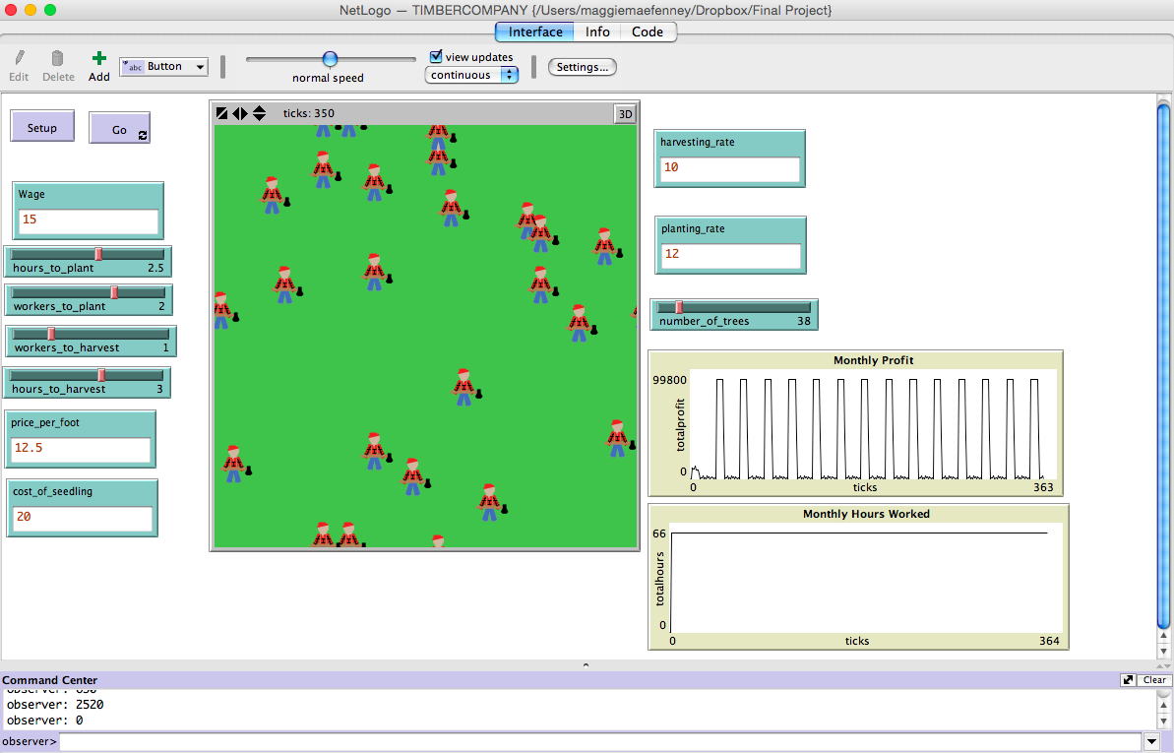
Example 2: This model represents the interaction if the user were to double the harvesting/planting rates.
- As pictured, this changes the interaction drastically. The profits increase every other month and decrease during the countering months.
  - There isn’t a steady profit.

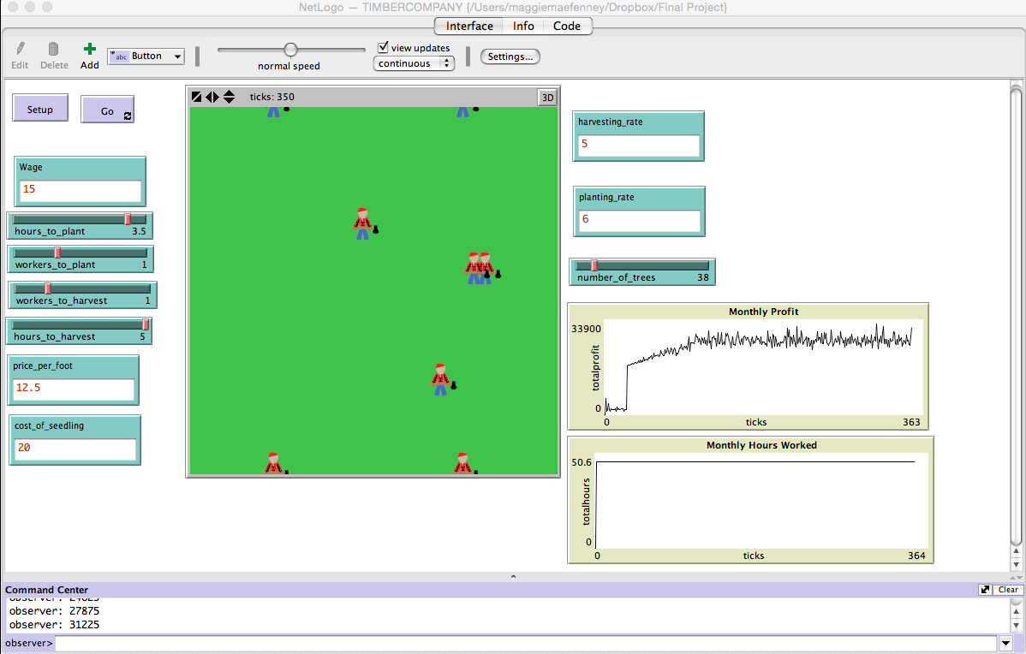
Example 3:The difference is the altered max number of hours to harvest/plant and min number of workers.
- The profit is what is affected the most. Although it is on an overall incline, there are various decreases of profits.
  - The screen is all green because the harvesters have cut what they were capable of, and planted more than what they have cut down.
  - *Keep in mind, in order for trees to be cut down they have to be a certain height*

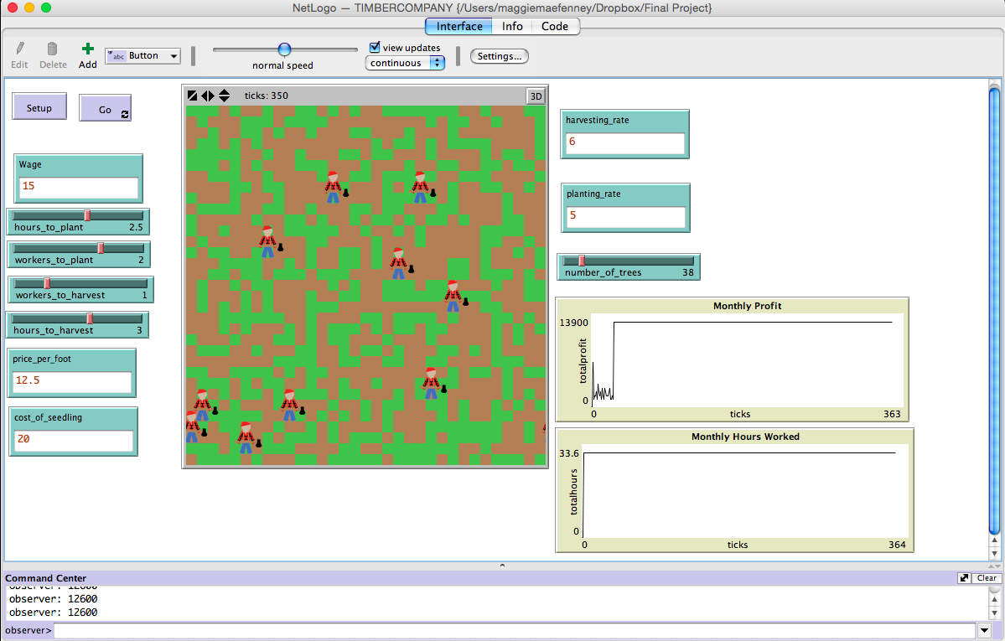Example 4: The difference is the switched harvesting/planting rates. the rates no are: harvest: 6, plant: 5
- This causes the profit to become consistent.
  - The result is at equilibrium; the harvesters are planting and harvesting the same amount thus producing the same profit each month.

Citations:

http://www.dragontrees.com/
"Fastest Growing Trees." Top 35. N.p., n.d. Web. 11 May 2015.
http://www.fast-growing-trees.com/Fastest-Growing-Trees.htm
"Make Millions Growing Empress Tree." The Daily South. N.p., 27 Apr. 2009. Web. 11 May 2015.
http://thedailysouth.southernliving.com/2009/04/27/make-millions-growing-empress-tree/
"Paulownia Tree Company - Fast Growing Flowering Royal Empress Shade Trees." Paulownia Tree Company - Fast Growing Flowering Royal Empress Shade Trees. N.p., n.d. Web. 11 May 2015.

