Elisabeth, Zach & Dante
Biology and the Game of Life
Timber Company Harvest Strategy

I. Overview- The Timber Model

A) Purpose

The Timber model addresses harvesting strategies for timber companies with western redwood cedar forests. The western redwood cedar trees typically take 30 or more years to grow from sapling to harvestable timber. Due to its relatively slow growth rate, most timber companies will select several locations of harvestable land, cycling through each location, allowing for full-growth forest for each harvest. With this in mind, our model displays forest with equally dispersed trees that are harvestable for timber market. The timber company in our model will either harvest from a square acre or move to the next neighboring acre depending on pricing incentives.
The model is formatted to generate maximal profits for the timber company considering harvestable trees and budgets. The model assumes one timber company for 180 by 180 plot of land divided into thirty six 30 by 30 square acres. For each month (tick), the model will determine how much wood to harvest given retention laws, as well as an optional time to move to a different, optimally priced square acre of land. In this way, the model explores how environmental and economic pressures influence optimal profit yields.
Based on user inputted selling prices, the model will generate a bell curve to predict future pricing possibilities for the consecutive six-months. From these six future price predictions, the model will optimize profit by either harvesting at the current square acre or moving to another square acre of harvestable land. The timber company will move when it detects a decrease in predicted profits for a given month. The model also incorporates a deductive moving cost in the overall profit. The final profit for each month are represented by a graph for each month.

II. Outline

A) Agents

- turtles: timber company (mobile) [red "X"]
- observer: The User
- patches: soil [black] and trees [green] (2.5 m) ₁

B) Variables

Globals:

- price-current (predicted price of timber for current month)
- price-1 (predicted price of timber for next month)
- price-2 (predicted price of timber for 2nd month)
- price-3 (predicted price of timber for 3rd month)
- price-4 (predicted price of timber for 4th month)
- price-5 (predicted price of timber for 5th month)
- price-6 (predicted price of timber for 6th month)

- tickH (time/month when turtle harvests)
- tickM (time/month when turtle moves)

- profit (number of trees cut multiplied by the difference of predicted price of tree and price to harvest tree

- tree retention (often followed by state regulation) [slider]
- Current price per tree [input box]
- Estimated price of market's high, low, average prices per tree [input box]
- moving cost [input box]

Turtle/Patch:
Dynamic:
patch:
- tree

C) Scales

- 1 tick = 1 month
- 1 patch = 2.5 m²

D) Scheduling

- Determine the pricing for current month and subsequent six months. Use this to decide whether to move from the current square acre or harvest

Design

A) Basic principles

The basic component of this model is the timber company and it's ultimate goal to be a profitable business. Profit is determined by costs of harvests and selling price of timber. Our model incorporates the basic principle that the forest includes all harvestable trees, equally dispersed. The model also uses concept that the timber company will focus on a square acre to harvest for each month rather than harvesting at any location.

B) Emergence

As our model runs, predictions of selling prices will emerge as well as decision to move or harvest current square acre. The price predictions are based from the high, low, and average user inputted prices. From this, the model calculates 6 future prices (see code below). The predicted prices are taken randomly from a normal bell curve generated by the four prices the user inputs. From these price predictions, the model decides to either harvest or move depending on a foreseen profit or loss. The final resulting profit takes the predicted price from the current selling price.

C) Objectives

To cut down trees at a reasonable financial rate that supports the company while taking into account six-month price predictions and staying within retention laws.

D) Learning Prediction

The company decides whether or not to move to the next acre based on if their current location is still a good harvest site.

E) Stochasticity

We have incorporated a bell curve to estimate the price of wood over a six-months.

The company will be able to determine a rough price for wood based on where a random point falls on this curve.

F) Collectives

Observe collective profits (plot).
Observe collective health of forest (screen).

G) Observation

As the timber company harvests, the user can observe the remaining trees (green patches). The timber company's location is indicated by a red X on the screen.
Plot of profit per month.

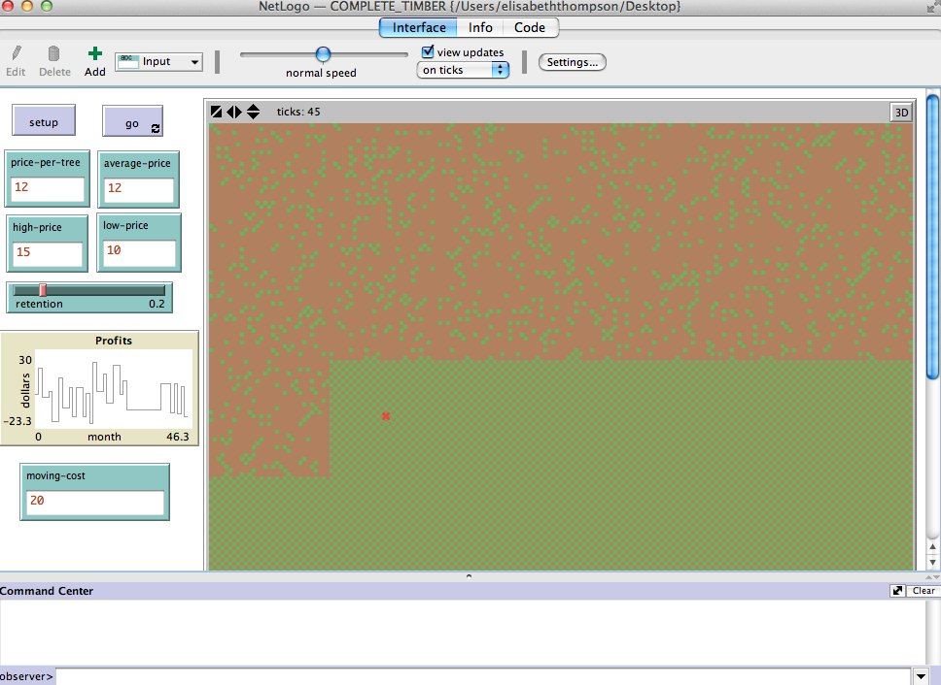

III. Description/Details

Initialization

There will be one timber company and a forest consisting of western redwood cedar trees planted at an appropriate distance apart. An initial bell curve will be computed based on supplied values for the high, low, and average recently observed price for cedar wood.

Default settings for the user inputs:

price-per-tree: $12
average-price: $12
high-price: $15
low-price: $10
moving-cost: $30

Settings:

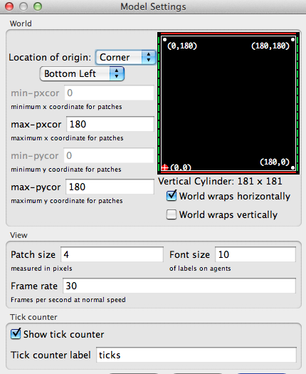
Format:
grid min xcor = 0 / max xcor = 180 / min o ycor = 0 / max ycor= 180 / patch size = 4

Setup:
- Initialize Company (red "X" on screen)
- Initialize Forest (green patches are green, brown patches are soil)
- Setup initial bell curve and six predicted prices for six ticks

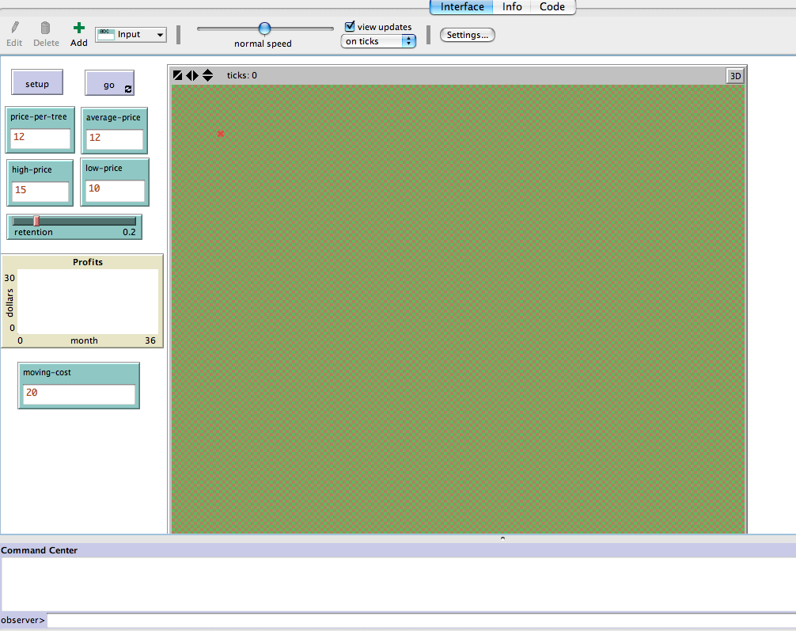
This is initial setup of the Timber model. Before the program runs, the forest has trees in a checkered pattern throughout the soil.

Go:
- The turtle (timber company) can possibly harvest.
- The turtle (timber company) possibly can move.
-Price-prediction will be updated for six month in advance (6-ticks).
-Profit output will be updated (results presented by graph).

To Move:

-Each time the turtle (or timber company) moves it will hop to an untouched neighboring square acre (30 patches away). The movement pattern has the company moving 30 acres to the right until it reaches the edge of forest, then moves down 30 acres and moves company to left, then moves down 30 acres and moves to the right, and so on until company has covered all the land in forest.

To Harvest:

- Determine number of trees to harvest based on current number of harvestable trees and retention rate.
- Remove trees from their acre ( also changing patch color from green to brown).

Citations:

1. Western red cedar. I. Forintek Canada Corp. II. Western Red Cedar Lumber Association. III. Title. IV. Se- ries: Special publication (Forintek Canada Corp.); no. SP-37R .

